Bay Area Deconstruction Policy Workgroup Meeting Notes
February 28, 2019

Welcome – Angela Sandoval, Manager, Zero Waste Office, EPA Region 9

- This group has been meeting quarterly for more than a year, and she thanked Nicole Tai of GreenLynx for convening the group and leading our efforts.

- Highlights of the group’s work -
  - The team at StopWaste – thank you Meri Soll -- has set up a website for our Workgroup where the meeting notes and presentations are posted:
http://www.stopwaste.org/recycling/deconstruction-workgroup

  - Workgroup members are actively promoting deconstruction and safe reuse at events across the state.

  - Seattle, King County and EPA Region 10 – inspired by Portland’s ordinance and our Workgroup, launched a Deconstruction Workgroup in Seattle in November with more than 60 attendees.

  - On the state level, CalRecycle is leading the charge with plans to keep organics out of landfills under AB 1383.

  - The state of California just closed their first-ever Pilot Reuse Grant Program with about $1 million in funding for reuse and is looking into a wood reuse emissions factor.

Presentations (View presentations at: http://www.stopwaste.org/recycling/deconstruction-workgroup)
- Brad Guy, Professor and Past Chair of USGBC’s Materials & Resources Technical Advisory Group, Catholic University School of Architecture
- Krista Kuehnhackl, Sustainability Coordinator, County of San Mateo Office of Sustainability
- Eden Brukman, Senior Green Building Coordinator, and James Slattery, Construction and Demolition Debris Recovery Specialist, San Francisco Department of the Environment
Brad Guy - Building Materials Reuse Trends, Research & the latest on LEED Reuse Credits

Loads of fascinating data and charts (see full presentation at Bay Area Deconstruction Workgroup website)

- US deconstruction/reuse foundations
  - AB 939 California Integrated Waste Management Act of 1989
  - Habitat for Humanity ReStores and charitable contribution federal tax credit
  - Corporate & personal leadership
  - Emergent properties
  - Circular economy, environmental justice, public health, embodied carbon
- U.S. reused materials trends strong
  - 2002 – 2019 – Change in Employment (Source: US. Economic Census)
    - All Retail + 0.4%
    - Used Merchandise +46.3%

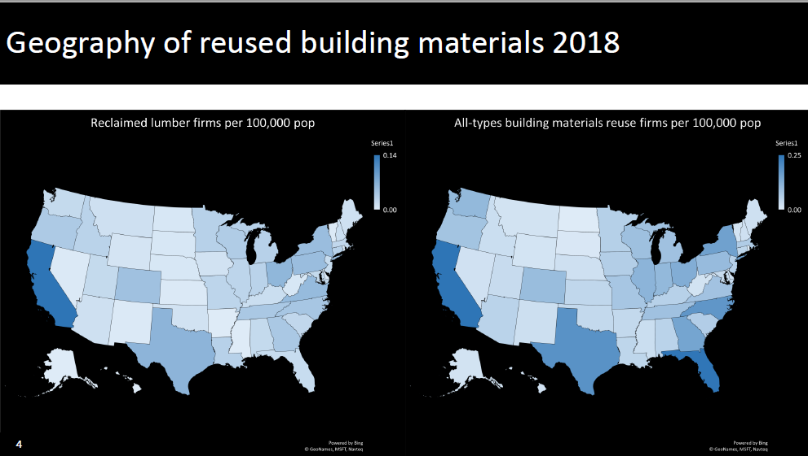

- Loads of fascinating data and charts
  - Strong reused building materials industry growth: 2005 – 779 to 2018 – 1820 reused building materials nonprofits & for profits.
  - Nonprofit sector dominated by Habitat for Humanity ReStores
  - 2018: ~98% of lumber-focus are profit firms nationally & 100% in CA
  - California 2018 – 152 reused building materials orgs & 36% are lumber-focus
- Shared overview of DC Green Building and C&D/reuse policies and incentives
- Provided in-depth look at LEED Materials & Resources Credits (highlights)

Building Life-Cycle Impact Reduction

Option 1: Historic Building Reuse; no threshold for compliance (5 pts).
Option 2: Renovation of Abandoned or Blighted Building; reuse at least 50% of surface area, and if more than 25% of building is to-be-demolished, project is ineligible for this option, must use Option #3 (5 pts).
Option 3: Building and Material Reuse; reuse or salvage building materials from on or off-site.
Path 1: Combination of reuse or salvage structural and non-structural elements from on or off-site (25% -2 pts: 50% -3 pts: 75% -4 pts).
Path 2 a/b: a. Maintain only structure and envelope of walls, floors and roofs (25% -1 pt: 50% -2 pts: 75% -3 pts); b. Maintain interior non-structural elements at least 33% by area of completed building, including additions (1 pt).
Option 4. Whole-Building Lifecycle Impact Reduction

- Path 3 - life-cycle assessment of the project’s structure and envelope… a minimum 10% reduction in 3 of the 6 environmental impacts including global warming potential (GWP) (3 pts).
- Path 4 – meet Path 3 and incorporate building reuse and/or salvage materials into the structure and envelope for the proposed design. Demonstrate a minimum 20% reduction in GWP and 10% reduction in an additional 2 environmental impact categories (4 pts).

LEED Responsible Sourcing of Raw Materials Criteria

Materials reuse, including salvaged and refurbished products, valued at 200% of cost for credit.

Material Reuse – Value Calculation
• Cost paid or replacement value whichever is higher.
• If actual cost below equivalent new item cost, use higher value.
• Source location distance is 0 for reuse of materials from project site.
• May use salvage from same Owner from another site.
• Furniture from same Owner and another site, must have been purchased at least 2-years prior to “reuse”.
• Salvage directly from other sites or third-party reuse store, source location is last location before reuse, either another site or the reuse store.

Indoor Environmental Quality – Reuse
Low emitting material (1-3 pts based on number of products)
Flooring and Ceilings, Wall Panels and Composite Wood, and Furniture includes “salvaged and reused materials criteria”
Construction & Demolition Waste Management
Option 2: Reduction of total waste material (2 pts)
Do not generate more than 7.5 lbs/SF of new construction waste, and for renovation and demolition waste, salvage or recycle at least 75%, not including Alternative Daily Cover (ADC) (required).

LEED Commercial Interiors
122 projects analyzed – total $4.6 million reuse value = ~$37,000/project
Top Areas: #1 – Wood 33%; #2 Finishes 26%; #3 Openings 15%

Resources

- EPA/AIA/BMRA Lifecycle Building Challenge http://www.lifecyclebuilding.org
- Public Architecture, Design for Reuse Primer (USGBC-funded)
https://issuu.com/publicarchitecture/docs/design_for_reuse_primer_issuu
- Deconstruction Project https://www.deconstructionproject.com

Krista Kuehnhackl – Deconstruction Trainings

Request for Quotes for Deconstruction Training contract released on September 2018 and signed by both parties February 2019.

Inspired by Portland’s presentation at first Bay Area Deconstruction Workgroup Meeting and decided to develop deconstruction training program

Contract awarded and Deconstruction Trainings are planned this summer:
  - 3 overview trainings – two days (inmates, general public, and construction & demolition professionals)
  - 2 intensive trainings – 12 days (inmates and general public)
  - Optional Crew Chief Training – two days
  - Trainings will use 2 single family homes under 1,600 square feet
  - 12 Day Course Outline
Day 1 - Classroom presentation on tools, safety, fixtures, and a quiz
Day 2 - Learn in the field about removing fixtures (sinks, toilets, etc.)
Days 3 and 4 - Classroom discussion on what was done right and wrong in
the field, learn about removing framing and banding lumber and a quiz
Days 5 through Day 11 - Take the house down
Day 12 - Wrap up in the classroom with a test, graduation and certificates!
  - See Request for Quotes and Training Flyer under Resources and registration link at https://freedeconstruction12daycoursemp.eventbrite.com
Eden Brukman and James Slattery – Discussion on Focusing Workgroup Priorities [I missed most of this session – please edit]
- Workgroup has grown and shared many helpful presentations over the past year
- As the group matures we are interested in leading efforts to identify stakeholders and prioritize Workgroup opportunities and activities
- Shared example of Flow Diagram sharing interactions between various green building organizations (attached)
- Plan to develop materials with the Workgroup online and share at the next Workgroup meeting.
For more information or to access draft documents, contact Shoshana Micon at shoshana.micon@sfenvironment.org or (415) 355-5018.

