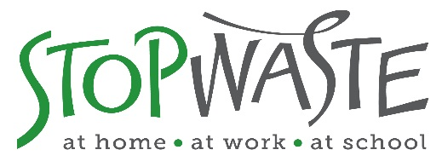

Measure D Funding Priorities

Building and Landscape eligible items for Measure D reimbursement.
This is a partial listing of the full Measure D reimbursement eligible items.
.

Sustainable Landscapes

- ReScape California Rated Landscapes (formerly known as Bay-Friendly Rated Landscapes).

Two tiers of funding based on the size of the Rated landscape.

- For landscapes under an acre and at least 5,000 sq. ft. – $50,000 of Measure D funds
- For landscapes an acre or greater - $100,000 of Measure D funds
- Measure D Funds should not exceed the cost of the project

  - Landscape recognized as ReScape CA Rated Landscape with ReScape CA
  - The project hired a ReScape Rater (as qualified by ReScape CA) ideally in the design phase or earlier.
  - It is recommended that the project landscape architect is a ReScape Qualified Landscape Professional

- Civic lawn conversions to low water landscapes using sheet mulch.
For lawn conversions >10,000 sq. ft., $25,000 of Measure D funds for projects that meet the StopWaste Lawn to Landscape Checklist requirements.

- Buying Recycled Compost and Mulch cover 100% of cost of materials, transportation and labor to install local and recycled compost and recycled mulch. Visit lawntogarden.org marketplace for resources on eligible mulch and compost products.

- Recycled Content or Salvage Landscape Materials cover complete cost for recycled content or salvaged landscape items.

- Sending staff to ReScape Professional Landscape Trainings
Staff time/labor costs and registration fees covered by Measure D.

- Pay 50% of a WELO enforcement contractor fees – contractor (or staff position) hired by city to ensure WELO requirements, including compost and mulch use, are enforced.

Sustainable Buildings

- USGBC LEED Certified Buildings

Project must be greater than 50,000 sq. ft. of conditioned space to receive $50,000 of mitigation funds to offset the costs to certify building(s) with the USGBC LEED program.

- The project must be registered and certified (minimum Silver Rating) with USGBC LEED
- The project must complete the following waste diversion/reuse credits:
  - Building Reuse: if applicable, building reuse required through credit Option 1, 2 or 3.
  - Sourcing: credit Option 2 required, purchasing salvaged and recycled content products
  - C&D: Project must attain a 75% C&D material diversion rate
  - RCI Pilot Credit 87: Project must utilize 3rd Party Mixed C&D Certified Facility (facility list available at Recycling Certification Institute )

- Cradle to Cradle Certified Products (C2Certified)

  - Purchase and utilize products found in Cradle to Cradle Certified Products Registry under the following categories:

    - Building Supply and Materials
    - Interior Design and Furniture (Roll carpet excluded)

A maximum of $100,000 per product type will be eligible for Measure D reimbursement to align with the intent of Measure D funding.

Program Manager of Measure D funds distribution is Meri Soll at msoll@StopWaste.org
Program Manager of Landscape Partnerships is Jennifer West at jwest@StopWaste.org

