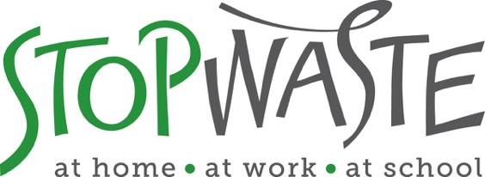

**Food Waste Prevention & Recovery Grants APPLICATION PACKET**

**DEADLINE:**

**Friday February 25, 2022**

**Applications must be received by 5:00 PM**

StopWaste  
1537 Webster Street, Oakland, CA 94612  
(510) 891-6500 • www.StopWaste.org

Table of Contents

Food Waste Prevention & Recovery Grant Focus Area Information 3

Food Waste Prevention & Recovery Grant Application 4

Project Budget 14

Standard Funding Agreement 14

Directions for Submitting Application and Supporting Documents 15

Appendix A – Example of Valid Insurance 16

Appendix B – Budget Spreadsheet Example 17

# Food Waste Prevention & Recovery Grant Focus Area Information

This is the application for Food Waste Prevention & Recovery Grants, which provide funding for innovative projects that incorporate activities that prevent food from going to waste and/or recover edible surplus food to feed people through food donation.

The goal is to prevent edible surplus food from being generated or going to compost or landfill and instead ensure its highest and best use—to feed people. In addition to addressing the issue of food insecurity, grant-funded projects conserve natural resources and prevent greenhouse gas emissions by preventing food from going to waste and keeping it out of landfill. Also eligible for funding are projects that eliminate the wasting of edible food through product or process redesign. **Maximum grant request is $20k.**

***PLEASE NOTE: Applicant can only submit ONE grant application for ONE focus area. See all available grant focus areas***[***here***](https://www.stopwaste.org/at-work/stopwaste-grants)***.***

Applicants **are strongly encouraged to consult** StopWaste staff for assistance regarding proposal concepts. Please contact Cassie Bartholomew at [cbartholomew@stopwaste.org](mailto:cbartholomew@stopwaste.org) with questions regarding this grant application.

StopWaste staff will hold office hours every Friday from 11 am-1 pm starting January 14th through February 18th 2022. To book an appointment, click [here](https://calendly.com/reusegrants).

Please review the [Waste Prevention Grant Program Information Packet](https://www.stopwaste.org/resource/grant-program-information-packet)  before starting the application as it contains important details such as Grant Program Overview, Eligible/Ineligible Grant Activities, Proposal Evaluation Criteria as well as General conditions.

**GRANT TIMELINE OVERVIEW:**

* **Grants Open**: January 5, 2022
* [**Informational Webinar:**](https://stopwaste.zoom.us/webinar/register/WN_LPdaMugWT7WBoVruSOfeVQ) January 20th, 2022 at 4:00PM [(Register Here)](https://stopwaste.zoom.us/webinar/register/WN_YmrSrdxtTzKfeFhddBl9zw)
* **Grant Applications Due**: February 25, 2022
* **Grantees Announced**: April 11, 2022
* **Grant Funding Agreements Executed**: June 1, 2022

# Food Waste Prevention & Recovery Grant Application

## General Information

Organization Name:

Website:

Contact Name (first and last):

Email Address:

Project Name:

Grant Amount Requested (max. $20,000): $

Total Project Budget: $

## Grant Proposal Details

### Organization/Business Overview

Briefly describe the history, purpose and primary activities of your organization or business. Indicate the qualifications of your organization to provide the proposed services and note any similar projects previously implemented by your group. Indicate your geographic area of operations, community providing services to, and the primary sources of financial support for your organization.

***300 words max***

|  |
| --- |
|  |

### 

### Project Details

Describe the specific purpose for which you are requesting funds.

* Include project design, primary activities, and essential equipment involved. Past grantees seeking additional grant funding to include how outcomes build on previous accomplishments.
* Indicate overall goals of the project, project implementation timeline (from start to end), and the anticipated impact of the project. Goals should be specific, realistic, timely, and measurable.
* Define the target focus of your project, including type of surplus food prevented and/or recovered, sources or sectors generating surplus edible food, and audiences served by your project.

***500 words max***

|  |
| --- |
|  |

1. **Statement of Need**

* Identify the issue, need, or gap your project seeks to address.
* Describe how your project will be inclusive, provide access and resources to marginalized communities, and not duplicate efforts of other organizations doing similar work.
* Provide details on the communities/businesses to whom recovered food is distributed.

|  |
| --- |
|  |

1. **Equity and Community Involvement**

* Referring to your proposed project and/or your organization’s work in general, please describe efforts to advance equity and inclusion in your organization, in your community, and/or through your programs and services in one or more of the following areas:
  + Increasing access for those in need of food, products and /or services.
  + Improving the community by offering education, training, recreation or other lacking services.
  + Job training and creation of jobs for marginalized and/or under-employed community members.
  + Working with and supporting community organizations in your community.
  + Other
* How is your organization rooted in your community? Describe how you are best positioned to provide support to your community with the proposed project. Include available data relative to these unmet/underserved needs in the targeted sectors.

*NOTE: If you have addressed equity and community involvement in response to previous questions, no need to repeat. Just reference the question response(s) that contain(s) the information.*

|  |
| --- |
|  |

1. **Waste Diversion**

* Quantify the amount and types of surplus food that will be prevented, reused, or recovered. Explain the methodology by which you will measure diversion, e.g., use of scales, counts of containers or materials, software, estimated waste based on volume, etc. Weight based measurement is required.
* If operating for-profit food service, please provide:
  + Number and type of meals served daily, number of seats, and square footage of food facility where meals are served.
  + Pounds of surplus food currently donated (if applicable).
  + Anticipated additional pounds of food that will be donated because of the grant project (if applicable).
* If operating an organization that recovers food to feed people, please provide:
  + Number of people served annually.
  + Number of meals served annually.
  + Pounds of donated/recovered surplus food distributed annually.
  + Pounds of purchased food distributed annually.
  + Anticipated additional pounds of surplus donated food that will be distributed annually because of the grant project.

|  |
| --- |
|  |

**6. Project Operations**

* List the personnel, with position titles and staff or volunteers who will work on the project. Indicate their relevant past experience and their primary responsibilities under this grant.
* List any applicable permits or licenses needed for project activities.
* List the names of all entities, food generators or donors, food recovery organizations or other key partners that your organization donates to or recovers food from, as well as their location.
* List the names and locations of feeding and distribution organizations that will receive donated surplus food.
  + Will any driving be involved for the proposed project? If yes, please describe (will staff or volunteers be driving, in personal or company vehicles, etc.).

|  |
| --- |
|  |

**7. Project Monitoring**

* + Indicate how program performance will be monitored and measured; explain how you will determine the success of the project.

|  |
| --- |
|  |

**8. Cost Effectiveness**

* + Describe why the project is an efficient use of public funds and resources.
  + Where applicable:
  + state the estimated cost savings in solid waste diversion,
  + the extent of economic activity generated through the prevention and or recovery of surplus edible food,
  + the savings realized through a food waste reduction program,
  + the number of jobs created by this project, etc.

|  |
| --- |
|  |

**9. Partnerships**

* + Describe any cooperative or collaborative efforts with other organizations that are specific to the implementation of the proposed grant activities.
  + Provide examples of how your organization has worked collaboratively with others.
  + Describe other project participant roles and indicate how resources are shared and service duplication avoided.
* Describe how you cooperate with other organizations to elevate their work and jointly support the community.
* If you plan to utilize a **Fiscal Sponsor**, please describe your organization’s relationship with them, the length of time for which they have served as your sponsor and list the contact person (name, email, phone) through which they can be reached. Please note that applicants MUST contact [Msoll@stopwaste.org](mailto:Msoll@stopwaste.org) for pre-authorization to utilize a Fiscal Sponsor prior to submittal of this grant application.

|  |
| --- |
|  |

**10. Long Term Self-Sufficiency**

* + StopWaste aims to invest in projects that demonstrate a commitment to sustainability that do not rely on continuous ongoing support from the grants program. Discuss how the project will become financially viable and self-sustaining after the expiration of the current grant.
  + Provide details on how future expenses will be met. E.g., fee for services/products or funding from other organizations, memberships, events as well as absorption of project into the overall budget of organization.

|  |
| --- |
|  |

# 

# Project Budget

All applicants must utilize our [standard budget form](http://www.stopwaste.org/resource/grant-budget-template) that shows the proposed project includes a reasonable itemized budget and leverages other resources (matching grants, in-kind support, service fees, sales, etc.)

The applicant must provide details in the standard budget form on how requested funds for this grant will be used. If the proposed grant request is only a portion of what the applicant needs to implement the proposed project, the applicant must include additional funds needed and source of those funds in order to complete project in the standard budget form.

Download the [template spreadsheet](https://www.stopwaste.org/resource/grant-budget-template), save as a PDF and follow the submittal directions below. Sample of a completed budget available in Appendix B.

# Standard Funding Agreement

By submitting this application, you certify that:

* You have reviewed the Agency’s standard funding agreement available at <http://www.stopwaste.org/resource/recycling-board-sample-funding-agreement> and, if awarded funding, your organization will comply with all of the terms set forth in the funding agreement. You will not request any changes to the basic agreement, items 1 – 10, Exhibits B and C.
* You understand that Exhibit A of the funding agreement will be customized to the grant project in regard to scope of services, deliverables, and timelines associated with funding request but that *no other changes to the standard funding agreement will be made*.
* You understand that failure to comply with any of these requirements will result in StopWaste’s refusal to enter into a Grant contract with your organization.
* You maintain (or have acquired a quote from insurance entity) that meets Agency’s [minimum insurance requirements](https://www.stopwaste.org/sites/default/files/StopWaste%20Insurance%20Requirements%202021.pdf).
* You have reviewed StopWaste’s [Grants Program and Financial Reporting Overview](https://www.stopwaste.org/resource/grants-financial-reporting-overview) for further information detailing the Funding Agreement, Payment, and Reporting Requirements should applicant be awarded funds.
* You have reviewed [Waste Prevention Grant Program Information Packet](https://www.stopwaste.org/resource/grant-program-information-packet)
* If selected for grant award, the individual or organization’s project manager *may be required* to submit a Statement of Economic Interest Form [(Form 700)](https://www.fppc.ca.gov/forms.html#title2) as required by the State Fair Political Practices Commission.You will *be notified if you are required to complete this form upon award of funding – you do not need to complete as part of application process*

# Directions for Submitting Application and Supporting Documents

1. **Save** completed application (this Word document) as a PDF.
2. **Combine the following required documents into a** singular PDF:
   * StopWaste Grant Application PDF
   * Project budget (download fillable template [here](http://www.stopwaste.org/resource/grant-budget-template))
   * Financial statements – Profit and Loss, Balance Sheet for Calendar years 2020 and 2021
   * Valid business license or 501C documentation
   * Proof of ***current*** insurance (or quote/estimate) that meet [StopWaste requirements](https://www.stopwaste.org/resource/stopwaste-grant-program-insurance-requirements)
   * *If applicable* : Letter(s) of Support (applicable only for projects with identified partners)
   * *Links to external download sources for application materials will not be accepted (this includes Google Docs, Google Photos, Dropbox etc.).* *Singular PDF not exceed 20MB. Help combining multiple PDFs* [*available here*](http://www.stopwaste.org/help/combining-pdfs)***.***
3. **Complete the submission form and upload** **SINGLE PDF** (containing combined documents listed above) to [www.stopwaste.org/grants/online-grant-submissions](http://www.stopwaste.org/grants/online-grant-submissions)

Accessing and uploading documents and data **takes additional time to complete**, applicants should plan on spending at least thirty minutes to complete the application upload process.

## Deadline: 5:00 p.m. on February 25, 2022

**IMPORTANT DETAILS REGARDING THE 5:00 PM DEADLINE**

* Completed application packets are due by 5:00 p.m. on February 25, 2022**.**
* Incomplete, mailed, emailed, or faxed submissions will be automatically disqualified.
* The application submittal process includes uploading an application AND additional data via the StopWaste Grant Submissions Portal.
* Please take the time to familiarize yourself with the [application and submittal portal](http://www.stopwaste.org/grants) and required documentation submissions and formats well before the deadline.
* **The Submissions Portal shuts down promptly at 5:00 p.m**. on February 25, 2022, *submissions that are in process will be aborted*. The system will send an automated message notifying you if your application was received on time. If your application is not fully uploaded prior to the 5:00 p.m. deadline, it will not be considered for funding.

# Appendix A – Example of Valid Insurance

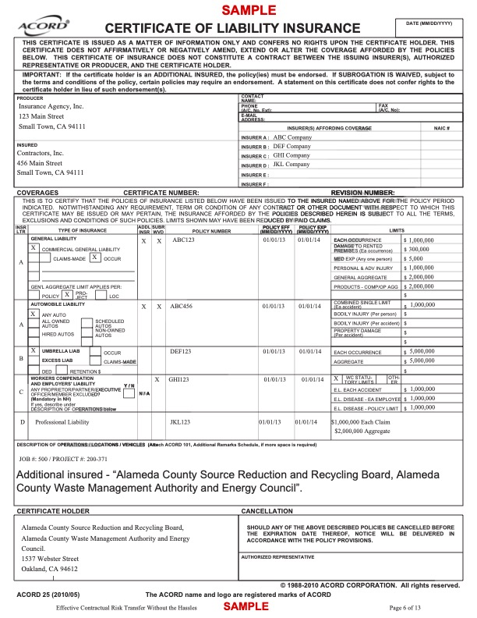

# Appendix B – Budget Spreadsheet Example

