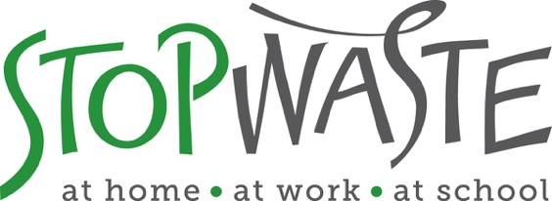

**Reusable Foodware Infrastructure and Services Pilot Projects**

**APPLICATION PACKET**

**DEADLINE:**

**Friday, February 25, 2022**

**Applications must be received by 5:00 PM**

StopWaste  
1537 Webster Street, Oakland, CA 94612  
(510) 891-6500 • www.StopWaste.org

Table of Contents

**Reusable Foodware Infrastructure and Services Pilot Projects**

Grant Application: Reusable Foodware Infrastructure and Services Pilot Projects 3

Application 4

Project Budget 13

Standard Funding Agreement 13

Directions for Submitting Application and Supporting Documents 14

Deadline: 5:00 p.m. on February 25, 2022 14

Appendix A – Example of Valid Insurance 15

Appendix B – Budget Spreadsheet Example 16

# Grant Application: Reusable Foodware Infrastructure and Services Pilot Projects

**About this grant category:**

Reusable foodware has the potential to significantly reduce consumption of single-use foodware, and StopWaste aims to develop local infrastructure and overall capacity for reusables in Alameda County so that these services are more accessible to businesses and consumers, without negatively impacting costs or compromising convenience. This grant category will provide funding for innovative projects that replace single-use, disposable foodware with reusable foodware systems. The idea is to demonstrate the feasibility of reusable foodware systems in a variety of settings with the long-term goal of developing local services and solutions that make reusable foodware the norm in Alameda County. StopWaste recognizes that building reusable foodware infrastructure is ground-breaking work that will require the testing of a range of approaches with the goal of gathering data and insights for possible scaling up in a later phase. The grant category is therefore intentionally framed as pilot projects.

Examples of projects of interest may include:

* Implementing reusables for on-site dining and/or takeout at cafés, restaurants, and institutional dining facilities
* Reusable cups, containers and other foodware items for on-site use at events and large gatherings
* Launching or expanding services that facilitate the use of reusables, such as dishwashing services, cup and container rental services, etc.
* Testing reusable solutions in real-world food-service scenarios to evaluate consumer demand and perception, and gather information on financial, operations, and environmental impacts
* Implementing reusable foodware systems operated by third-party vendors who provide, collect, wash, and redistribute the foodware
* Introducing reusable foodware for meal delivery apps and services, and other solutions that reduce the community’s dependence on single-use foodware items

**Funding Amount**

StopWaste has allocated $220,000 in total funding for this grant category. It is anticipated that most awards will range between $5,000-$50,000, although larger projects may be funded depending on expected geographic and environmental impact. If you plan to apply for a grant larger than $50,000, we recommend that you first discuss the project with Ben Duggan at [bduggan@StopWaste.org](mailto:bduggan@StopWaste.org).

**GRANT TIMELINE OVERVIEW:**

* **Grants Open**: January 5, 2022
* **Informational Webinar:** January 20, 2022, 4:00PM [(register here)](https://stopwaste.zoom.us/webinar/register/WN_YmrSrdxtTzKfeFhddBl9zw)
* **Grant Applications Due**: February 25, 2022, 5:00PM
* **Grantees Announced**: April 11, 2022
* **Grant Funding Agreements Executed**: June 1, 2022

# Application

**Before You Start**

Please review the [Waste Prevention Grant Program Information Packet](https://www.stopwaste.org/resource/grant-program-information-packet)  before starting the application as it contains important details such as Grant Program Overview, Eligible/Ineligible Grant Activities, Proposal Evaluation Criteria as well as General Conditions.

Given the innovative nature of this new grant category, applicants **are strongly encouraged to consult** **StopWaste staff** to get initial feedback on and assistance with proposal concepts, as well as to ask any questions regarding this grant application. Please contact Ben Duggan at [bduggan@stopwaste.org](mailto:bduggan@stopwaste.org).

**General Information** *(Applicant to complete all information below)*

### Organization Name:

Website:

Contact Name (first and last):

Email Address:

Project Name:

Grant Amount Requested:

Total Project Budget: $

Grant Proposal Details

1. **Reusable Foodware RFQ Response**

Have you submitted a response to StopWaste’s [RFQ for Reusable Foodware Services](https://www.stopwaste.org/resource/request-for-qualifications-reusable-foodware-support-and-services)?

Yes

No

NOTE: An RFQ submission **is not a prerequisite** for this grant application. Rather, having submitted an RFQ response indicates vetting by StopWaste and addition to the list of qualified reusable foodware service providers. If you are seeking partners for your grant proposal, please consider reaching out to entities listed on the [pre-approved list of reusable foodware service providers](https://www.stopwaste.org/reusable-foodware-service-providers). To submit your organization’s qualifications to be added to the list, [click here.](https://www.stopwaste.org/resource/request-for-qualifications-reusable-foodware-support-and-services)

1. **Qualifications and Organization/Business Overview**

Briefly describe the history, purpose and primary activities of your organization or business. Indicate the qualifications of your organization to provide the proposed services and note any similar projects previously implemented by your group. Indicate your geographic area of operations, audience you are providing services to, and the primary sources of financial support for your organization.

***300 words max***

|  |
| --- |
|  |

### 

1. **Project Details**

Describe the specific purpose for which you are requesting funds.

* Include project design, primary activities, where it will be implemented, and essential equipment involved.
* Indicate the overall goals of the project, the project implementation timeline (from start to end), and the anticipated impact of the project. Goals should be specific, realistic, timely, and measurable.
* Does your project provide any benefits to the audience served and/or other community members beyond waste prevention? Examples may include job training and/or employment for under-served community members, opportunity to build community and increase connectivity among community members, serve unmet needs such as increasing food security, etc.

***500 words max***

|  |
| --- |
|  |

1. **Project Operations**

* List the personnel, with position titles, who will work on the project. Indicate their relevant past experience and their primary responsibilities under this grant.
* List any applicable permits or licenses needed for project activities.

|  |
| --- |
|  |

1. **Project Evaluation**

* Indicate how program performance will be a) monitored and b) measured; explain how you will determine the success of the project.
* Quantify the amount and types of material(s) that will be prevented, reused, and/or recovered. Explain your metrics e.g., number of single-use items replaced, expected number of reuses per item, and the methodology by which you will measure impact, such as using software, estimating waste based on volume, etc.

|  |
| --- |
|  |

1. **Cost Effectiveness, Economic and Community Benefits**

Describe why the project is a good use of public funds and resources.

* Where applicable, evaluate the project’s costs and savings related to foodware:
  + - Estimated cost savings in solid waste prevention, e.g., purchases of single-use foodware avoided, waste handling labor and waste collection costs eliminated, etc.
    - Additional/new costs created by this project through purchasing reusables, washing, delivery, collection, etc.
* Discuss the extent of economic activity generated beyond reusable foodware purchases such as jobs created or supported for washing, collecting, and redistributing of foodware, job training provided, etc.
* Discuss community benefits realized through the project. See also question 3.

***300 words max***

|  |
| --- |
|  |

1. **Partnerships**

Pilot projects will preferably involve a partnership between several entities. These may include StopWaste and Alameda County jurisdictions, reusable foodware service provider(s), food service establishment(s), and others.

* Describe any cooperative or collaborative efforts with other organizations that are specific to the implementation of the proposed grant activities.
* Describe other project participant roles and indicate how resources are shared and service duplication avoided.

|  |
| --- |
|  |

1. **Equity and Community Involvement**

Referring to your proposed project and/or your organization’s work in general, please describe efforts to advance equity and inclusion in your organization, in your community, and/or through your programs and services in one or more of the following areas:

* Increasing access for those in need of food, products and /or services.
* Improving the community by offering education, training, recreation or other lacking services.
* Job training and creation of jobs for marginalized and/or under-employed community members.
* Working with and supporting community organizations in your community.
* Other

***NOTE: If* you *have addressed equity and community involvement in response to previous questions, no need to repeat. Just reference the question response(s) that contain(s) the information.***

|  |
| --- |
|  |

1. **Long Term Self-Sufficiency & Upscaling Potential**

This grant category is intentionally framed as funding for pilots, with the intent of using lessons learned to modify the project as needed for long-term viability without grant funding. Please discuss if/how the project might become financially viable and self-sustaining after the expiration of the current grant and/or what opportunities for scaling up might be unlocked through the pilot activities (e.g., identify opportunities to expand geographically or to a wider variety of disposable foodware items prevented, etc.). If applicable, provide details on how future expenses might be met, e.g., investment or grant funding opportunities once proof of concept is obtained, possible partnerships, etc.

|  |
| --- |
|  |

# 

# Project Budget

All applicants must utilize our [standard budget form](http://www.stopwaste.org/resource/grant-budget-template) that shows the proposed project includes a reasonable itemized budget and leverages other resources (matching grants, in-kind support, service fees, sales, etc.)

The applicant must provide details in the standard budget form on how requested funds for this grant will be used. If the proposed grant request is only a portion of what the applicant needs to implement the proposed project, the applicant must include additional funds needed and source of those funds, in order to complete the standard budget form for the proposed project.

Download and complete the [template spreadsheet](https://www.stopwaste.org/resource/grant-budget-template), save as a PDF and follow the submittal directions below. Sample of a completed budget available in Appendix B.

# Standard Funding Agreement

By submitting this application, you certify that:

* You have reviewed the Agency’s standard funding agreement available at <http://www.stopwaste.org/resource/recycling-board-sample-funding-agreement> and, if awarded funding, your organization will comply with all of the terms set forth in the funding agreement. You will not request any changes to the basic agreement, items 1 – 10, Exhibits B and C.
* You understand that Exhibit A of the funding agreement will be customized to the grant project in regard to scope of services, deliverables, and timelines associated with your funding request but that *no other changes to the standard funding agreement will be made*.
* You understand that failure to comply with any of these requirements will result in StopWaste’s refusal to enter into a Grant contract with your organization.
* You maintain insurance (or have acquired a quote from insurance entity) that meets Agency’s [minimum insurance requirements](https://www.stopwaste.org/sites/default/files/StopWaste%20Insurance%20Requirements%202021.pdf).
* You have reviewed StopWaste’s [Grants Program and Financial Reporting Overview](https://www.stopwaste.org/resource/grants-financial-reporting-overview) for further information detailing the Funding Agreement, Payment, and Reporting Requirements should applicant be awarded funds.
* If selected for grant award, the individual or organization’s project manager *may be required* to submit a Statement of Economic Interest Form [(Form 700)](https://www.fppc.ca.gov/forms.html#title2) as required by the State Fair Political Practices Commission.You will *be notified if you are required to complete this form upon award of funding – you do not need to complete it as part of application process.*

# 

# Directions for Submitting Application and Supporting Documents

1. **Save completed application (this Word document) as a PDF.**
2. **Combine the following required documents into a singular PDF:**
   * StopWaste Grant Application PDF (see #1 above)
   * Project budget (download fillable template [here](http://www.stopwaste.org/resource/grant-budget-template))
   * Financial statements – Profit and Loss, Balance Sheet for Calendar years 2020 and 2021
   * Valid business license or 501C documentation
   * Proof of ***current*** insurance (or quote/estimate) that meet [StopWaste requirements](https://www.stopwaste.org/resource/stopwaste-grant-program-insurance-requirements)
   * *If applicable*: Letter(s) of Support (applicable only for projects with identified partners)

*Links to external download sources for application materials will not be accepted (this includes Google Docs, Google Photos, Dropbox etc.).* *Singular PDF must not exceed 20MB. Help combining multiple PDFs into one is* [*available here*](http://www.stopwaste.org/help/combining-pdfs)***.***

3. **Complete the submission form and upload** **SINGLE PDF** (containing combined documents listed above) via this page: [www.stopwaste.org/grants/online-grant-submissions](https://www.stopwaste.org/node/3208)

Accessing and uploading documents and data **takes additional time to complete;** applicants should plan on spending at least 30 minutes to complete the application upload process.

# Deadline: 5:00 p.m. on February 25, 2022

* Completed application packets are due by 5:00 p.m. on February 25, 2022**.**
* Incomplete, mailed, emailed, or faxed submissions will be automatically disqualified.
* The application submittal process includes uploading an application AND additional data via the StopWaste Grant Submissions Portal, in one single PDF.
* Please take the time to familiarize yourself with the [application and submittal portal](https://www.stopwaste.org/node/3208) and required documentation submissions and formats well before the deadline.
* **The Submissions Portal shuts down promptly at 5:00 p.m**. on February 25, 2022. S*ubmissions that are in process will be aborted*. The system will send an automated message notifying you if your application was received on time. If your application is not fully uploaded prior to the 5:00 p.m. deadline, it will not be considered for funding.

# Appendix A – Example of Valid Insurance

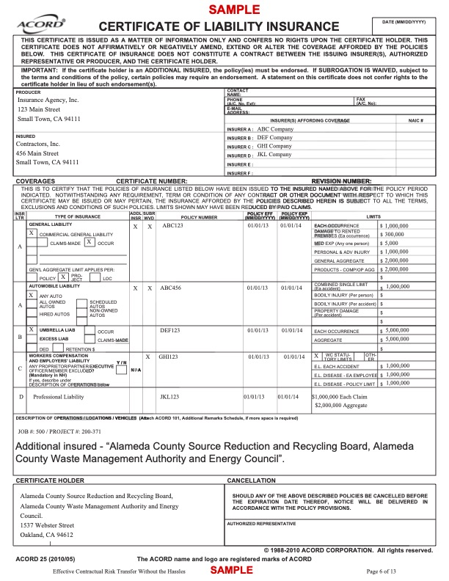

# Appendix B – Budget Spreadsheet Example

