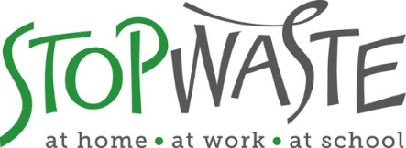

**2022 StopWASTE GRant Program  
Reusable Transport Packaging Grant Focus Area**

This is the application for the Reusable Transport Packaging grant focus area, which provides funding for equipment to support the switch from single- or limited-use packaging used in manufacturing, transportation, and/or distribution—to durable, reusable alternatives designed for many years of use.  
  
Typical examples of reusable transport packaging include:

* Durable plastic totes to replace cardboard shipping boxes
* Reusable mesh pallet wraps to replace disposable plastic wrap to secure pallet loads
* Durable pallets to replace typical wood pallets
* Durable intermediate bulk containers (IBCs) to replace single use gaylords/pallets

Reusable transport packaging projects must reduce transport packaging waste generated in Alameda County or reduce packaging used to transport materials/products originating outside of Alameda County that are shipped with an end destination in Alameda County. **Maximum grant request is $10k.**

* Please review the [Waste Prevention Grant Program Information Packet](https://www.stopwaste.org/resource/grant-program-information-packet)  before starting the application, as it contains important details such as Grant Program Overview, Eligible/Ineligible Grant Activities, Proposal Evaluation Criteria, as well as General conditions. Applicants will need to review and agree to the standard [funding agreement](https://www.stopwaste.org/resource/stopwaste-equipment-grant-agreement) and to the Agency’s [terms and conditions](https://www.stopwaste.org/resource/stopwaste-equipment-grant-terms-and-conditions).

NOTE: Applicants may only submit ONE grant application for ONE focus area. See all available grant focus areas [here](https://www.stopwaste.org/at-work/stopwaste-grants). Should your organization have needs that fall within multiple focus areas, please attend office hours (see below) or contact Michelle Fay, [mfay@stopwaste.org](mailto:mfay@stopwaste.org) to discuss options.

**Grant Application Support**

Applicants **are strongly encouraged** to work withStopWaste staff prior to submitting a grant application to ensure project concepts are eligible for potential funding. You may choose to attend office hours or schedule a free one-on-one consultation with an assistance representative:

* **Office hours** – held every Friday from 11 am-1 pm starting January 14th thru and February 18th 2022. To book an appointment, click [here](https://calendly.com/reusegrants).
* **One-on-one consultations** – phone, virtual, and in-person support is available to help identify product vendors, work through project logistics, or answer general questions about the grant program. Contact Michelle Fay at [mfay@stopwaste.org](mailto:mfay@stopwaste.org) to schedule.

**GRANT TIMELINE OVERVIEW:**

* **Grants Open**: January 5, 2022
* **Informational Webinar:** January 20th, 2022 at 4:00PM [(register here)](https://stopwaste.zoom.us/webinar/register/WN_YmrSrdxtTzKfeFhddBl9zw)
* **Grant Applications Due**: February 25, 2022
* **Grantees Announced**: April 11, 2022
* **Grant Funding Agreements Executed**: June 1, 2022

##### **Examples of Past Reusable Transport Packaging Grantees**

***Surplus Service: Bulk Bins & Carts***

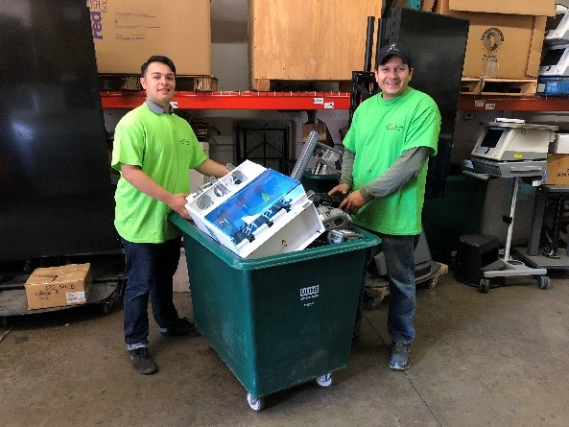Surplus Service is an e-waste recycler located in Fremont, CA with a focus on reuse and repair. Medical and electronic equipment was collected in cardboard gaylord boxes on pallets, and those were then recycled after a single use. These were replaced with sturdy wheeled bins to collect electronics at client sites and stackable reusable plastic bulk containers for use in the warehouse. This switch to reusables saves Surplus Service over $15,000 on avoided packaging costs each year.

***Veritable Vegetable: Reusable Pallet Wraps***

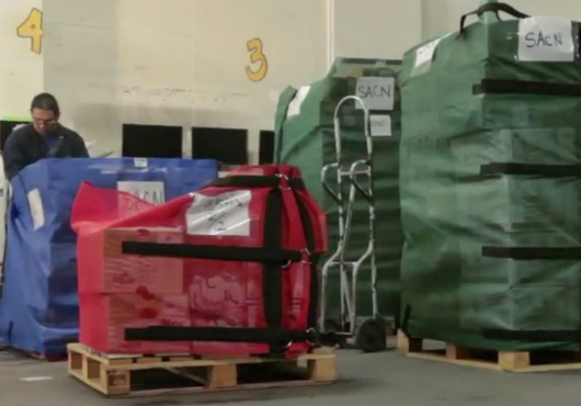Veritable Vegetable is an organic produce distributor located in San Francisco, CA. Prior to switching to reusables, they used over 700 miles of plastic wrap each year to secure produce boxes on pallets. The reusable pallet wraps prevent over a ton of plastic waste per year plus help prevent worker injuries. The distributor also saves over $6,000 per year on avoided plastic wrap purchasing costs.

***Full Belly Farm: Reusable Totes***

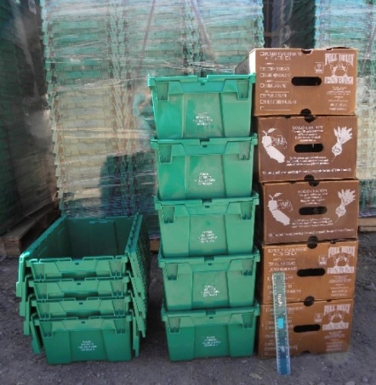Full Belly Farm grows seasonal organic produce and delivers directly to dozens of restaurants, markets, and residential member pickup sites throughout Alameda County. With help from a StopWaste grant, Full Belly Farm purchased 2,000 stackable plastic totes to eliminate the recurring purchase of waxed cardboard boxes for transporting produce. The reusables prevent more than 8,000 waxed cardboard boxes from going to landfill and save the farm over $14,000 in avoided cardboard purchases annually.

# Reusable Transport Packaging Grant Application

Please note you will be prompted to copy & paste some of your responses below into [the online submission form](http://www.stopwaste.org/grants/online-grant-submissions) when you are ready to submit your completed application.

Organization Name:

**Website**:

**Contact Name (first and last**):

**Email Address**:.

**Project Name**:

**Grant Amount Requested** (max. $10,000):

**Total Project Budget: $**

**Project Summary**

Briefly summarize (in 50 words or less) the specific purpose for which are you requesting funds. (Please note you will be prompted to copy & paste your response below into the “Project Summary” section on [the online submission form](http://www.stopwaste.org/grants/online-grant-submissions) when ready to submit your completed application.)

|  |
| --- |
|  |

**Organization or Business Mission**

Briefly summarize (in 50 words or less) the mission / business statement of your entity. (Please note you will be prompted to copy & paste your response below into the “Organization or Business Mission” section on [the online submission form](http://www.stopwaste.org/grants/online-grant-submissions) when ready to submit your completed application.)

|  |
| --- |
|  |

Proposal Details

**1. Project Status**

New

Expansion to existing project

Ongoing

**2. What type of transport packaging will you reduce or eliminate? (Check all that apply)**

Limited-use pallets

Plastic film / pallet wrap

Cardboard boxes

Gaylords

Fiber drums

Other (please describe):

**3. Are these materials currently landfilled, recycled, or composted?**

|  |
| --- |
|  |

**4. Do you purchase these materials or are they donated or otherwise received from another entity that purchases the transport packaging?** *Note: transport packaging must be eliminated at the source to be eligible for grant funding. If transport packaging materials are donated to your organization, e.g., a food pantry that reuses old cardboard boxes to transport edible food, it is likely the requested equipment will not result in the reduction of wasted packaging. In these cases, you may want to consider another* [*grant focus area*](https://www.stopwaste.org/at-work/stopwaste-grants) *that may better align with your proposed project.*

|  |
| --- |
|  |

**5. What type of reusable transport packaging do you want to purchase? (Check all that apply)**

Reusable totes or bins.

Durable pallets

Reusable pallet wrap, bands, or belts

Durable intermediate bulk containers (IBCs)

Other (please describe):

**6. Project Description**

Describe your proposed project and explain how the project activities/deliverables will help prevent waste from reusable transport packaging. Please include a description of how the reusables will be tracked and managed to prevent loss.

***300 word max***

|  |
| --- |
|  |

**7.How much waste will be prevented?***Please specify the amount and type of materials that will not need to be purchased due to implementation of the proposed project. Include size, quantity, and weight as well as dollar value of those materials being replaced. For example: “Purchasing 100 reusable totes that are cycled 10x/year replace 1,000 cardboard boxes; each disposable box is 2’x2’x4’, weighs 1 pound, and costs $5.00.”*

***300 word max***

|  |
| --- |
|  |
|

**8. Proposed Budget**

Give a break-down of the costs associated with the new reusable transport packaging equipment that is being requested under this grant application. Include quantity needed and the cost of each requested equipment type. Up to $10,000 total may be requested.

|  |  |  |  |  |  |
| --- | --- | --- | --- | --- | --- |
| **Reusable Transport Packaging Equipment\*** (one line per item type, add lines as needed) | **Anticipated Item Cost** | **Quantity** | **Tax** | **Shipping** | **Total Cost** |
| *Example: BrandABC handheld reusable tote – 20” x 14” x 12”* | *$25* | *200* | *$500.00* | *$150.00* | *$5,650.00* |
| Reusable totes or bins |  |  |  |  |  |
| Durable pallets |  |  |  |  |  |
| Reusable pallet bands, belts, or wraps |  |  |  |  |  |
| Durable intermediate bulk containers (IBCs) |  |  |  |  |  |
| Other equipment (describe) enter text. |  |  |  |  |  |
| enter text. |  |  |  |  |  |
| enter text. |  |  |  |  |  |
| **Total Equipment** |  |  |  |  |  |

*\*When possible, please provide links to online product pages and submit quotes for requested equipment including vendor name, product specifications, and pricing information in your application PDF.*

List any funding matches or in-kind contributions.

|  |
| --- |
|  |

**9. Measurement**

Indicate project goals/deliverables, and any indicators that will serve as a measure of success.

|  |
| --- |
|  |

**10. Project Timeline**

Present an implementation schedule for the project. The equipment must be purchased and the project implemented within 6 months of the start of the grant contract.

|  |
| --- |
|  |

**11. Personnel**List team members and expertise, as relevant for the proposed project.

|  |
| --- |
|  |

**12. Other Participating Organizations/Partners**

List any cooperative or collaborative efforts with other organizations that are part of your proposed project.

|  |
| --- |
|  |

**13. Equity and Community Involvement**  
Referring to your proposed project and/or your organization’s work in general, please describe efforts to advance equity and inclusion in your organization, in your community, and/or through your programs and services in one or more of the following areas:

* + Increasing access for those in need of food, products and /or services.
  + Improving the community by offering education, training, recreation or other lacking services.
  + Job training and creation of jobs for marginalized and/or under-employed community members.
  + Working with and supporting community organizations in your community.
  + Other

*NOTE: If you have addressed equity and community involvement in response to previous questions, no need to repeat. In the space below, simply reference the question response(s) that contain(s) the information.*

|  |
| --- |
|  |

# Directions for Submitting Application and Supporting Documents

1. **Save completed application (this Word document) as a PDF**.
2. **Combine the following required documents into a singular PDF:**
   * StopWaste Grant Application PDF
   * Valid business license or 501C documentation
   * If applicable: Letter(s) of Support (applicable only for projects with identified partners)

*Links to external download sources for application materials will not be accepted (this includes Google Docs, Google Photos, Dropbox etc.).* *Help combining multiple PDFs into one is* [*available here*](http://www.stopwaste.org/help/combining-pdfs)***.***

**3. Complete the submission form and upload** **SINGLE PDF** (containing combined documents listed above) to [www.stopwaste.org/grants/online-grant-submissions](http://www.stopwaste.org/grants/online-grant-submissions)

*Accessing and uploading documents and data* ***takes additional time to complete****, applicants should plan on spending at least thirty minutes to complete the application upload process.*

**Deadline: 5:00 p.m. on February 25, 2022**

**IMPORTANT DETAILS REGARDING THE 5:00 PM DEADLINE**

* Completed application packets are due by 5:00 p.m. on February 25, 2022**.**
* Incomplete, mailed, emailed, or faxed submissions will be automatically disqualified.
* The application submittal process includes uploading an application AND additional information via the StopWaste Grant Submissions Portal.
* Please take the time to familiarize yourself with the [application and submittal portal](http://www.stopwaste.org/grants) and required documentation submissions and formats well before the deadline.
* **The Submissions Portal shuts down promptly at 5:00 p.m**. on February 25, 2022. S*ubmissions that are in process of upload will be aborted*. The system will send an automated message notifying you if your application was received on time. If your application is not fully uploaded prior to the 5:00 p.m. deadline, it will not be considered for funding.