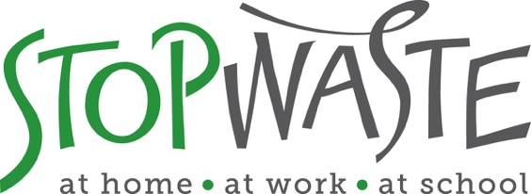

**Reusable Transport Packaging Grant**

**Application Packet**

**DEADLINE:**

**March 15, 2021**

**5:00 PM**

StopWaste  
1537 Webster Street, Oakland, CA 94612  
(510) 891-6500 • www.StopWaste.org

Table of Contents

[About StopWaste 3](#_Toc62741599)

[StopWaste Grants Program 3](#_Toc62741600)

[Application Prerequisites 5](#_Toc62741601)

[Proposal Evaluation Criteria 6](#_Toc62741602)

[Directions for Application Submission & Due Date 7](#_Toc62741603)

[Reusable Transport Packaging Grant Application 8](#_Toc62741604)

[General Conditions 13](#_Toc62741605)

[Insurance Requirements 14](#_Toc62741606)

[Standard Funding Agreement 14](#_Toc62741607)

[Appendix A – Example of Valid Insurance 15](#_Toc62741608)

# About StopWaste

StopWaste is a public agency responsible for reducing waste in Alameda County. We help local governments, businesses, schools, nonprofits, and residents reduce waste through:

* Prevention, Reuse, Compost, and Recycling programs,
* Market Development,
* Technical Assistance and Funding Support,
* Public Education.

We are governed jointly by three boards, the Alameda County Waste Management Authority, the Alameda County Source Reduction and Recycling Board, and the Energy Council.

# StopWaste Grants Program

StopWaste is currently accepting applications (February 1 – March 15) for four different grant opportunities with total funding for 2021 up to $475k available to nonprofits, businesses, and institutions. Grants are aimed at increasing individual, business, and community involvement in the prevention of waste in Alameda County.

There are four specific focus areas for the 2021 StopWaste grants program:

* [Food Waste Prevention and Recovery](https://www.stopwaste.org/at-work/stopwaste-grants/food-waste-reduction-grants)
* [Surplus Food Donation Equipment](https://www.stopwaste.org/at-work/stopwaste-grants/surplus-food-donation-equipment-grants)
* [Reuse and Repair](https://www.stopwaste.org/at-work/stopwaste-grants/reuse-and-repair-grants)
* [Reusable Transport Packaging](https://www.stopwaste.org/at-work/stopwaste-grants/reusable-transport-packaging-grants)

**PLEASE NOTE:** Applicants may only submit one grant application for one focus area. Review all grant focus areas [here](https://www.stopwaste.org/at-work/stopwaste-grants) to identify the one program that will best fit your needs.

Applicants with open StopWaste grants must check with their grant managers to assess if they are eligible for additional grant funding.

**Reusable Transport Packaging Grants**

This is the application for the Reusable Transport Packaging grant focus area, which provides funding for equipment to support the switch from single- or limited-use packaging used in manufacturing, transportation, and/or distribution—to durable, reusable alternatives designed for many years of use.  
  
Typical examples are the replacement of cardboard boxes with durable plastic totes and switching from disposable plastic wrap to secure pallet loads, with reusable mesh pallet wraps.  
  
Reusable transport packaging projects must reduce transport packaging waste generated in Alameda County or reduce packaging used to transport materials/products originating outside of Alameda County that are shipped with an end destination in Alameda County. **Maximum grant request is $10k.**

##### **Examples of Past Reusable Transport Packaging Grantees**

***Surplus Service: Bulk Bins & Carts***

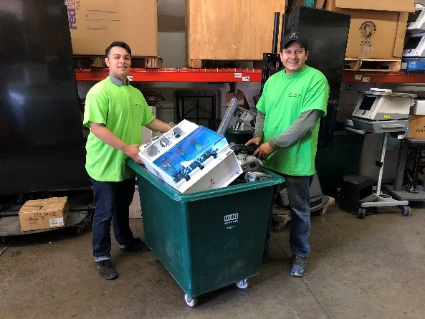Surplus Service is an e-waste recycler located in Fremont, CA with a focus on reuse and repair. Medical and electronic equipment was collected in cardboard gaylord boxes on pallets, and those were then recycled after a single use. These were replaced with sturdy wheeled bins to collect electronics at client sites and stackable reusable plastic bulk containers for use in the warehouse. This switch to reusables saves Surplus Service over $15,000 on avoided packaging costs each year.

***Veritable Vegetable: Reusable Pallet Wraps***

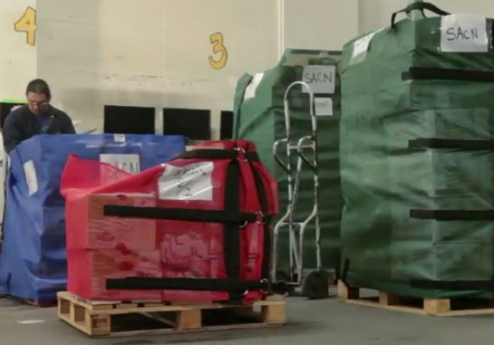Veritable Vegetable is an organic produce distributor located in San Francisco, CA. Prior to switching to reusables, they used over 700 miles of plastic wrap each year to secure produce boxes on pallets. The reusable pallet wraps prevent over a ton of plastic waste per year plus help prevent worker injuries. The distributor also saves over $6,000 per year on avoided plastic wrap purchasing costs.

***Full Belly Farm: Reusable Totes***

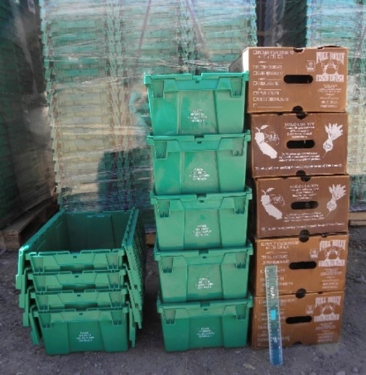Full Belly Farm grows seasonal organic produce and delivers directly to dozens of restaurants, markets, and residential member pickup sites throughout Alameda County. With help from a StopWaste grant, Full Belly Farm purchased 2,000 stackable plastic totes to eliminate the recurring purchase of waxed cardboard boxes for transporting produce. The reusables prevent more than 8,000 waxed cardboard boxes from going to landfill and save the farm over $14,000 in avoided cardboard purchases annually.

# Application Prerequisites

**PROPOSED PROJECTS MUST:**

* Reduce transport packaging waste generated in Alameda County or reduce packaging used to transport materials/products originating outside of Alameda County that are shipped with an end destination in Alameda County.
* Be implemented within 6 months of contract execution.

**APPLICANTS MUST:**

* ONLY SUBMIT ONE APPLICATION TO ONE grant focus area. This is the application for the Reusable Transport Packaging focus area.
* Must be a valid business, institution, or non-profit.
* Not use a Fiscal Sponsor unless the Fiscal Sponsor is specifically set up to offer their legal and tax-exempt status to applicant with a fee based contractual arrangement. You must receive approval to utilize a Fiscal Sponsor from StopWaste prior to submittal of application. Contact [Msoll@stopwaste.org](mailto:Msoll@stopwaste.org) for more information.
* Maintain insurance that meets Agency minimum criteria linked [here](#_Acknowledgement_of_Required); see appendix A for [sample insurance documentation](#_Appendix_A:_Example).
* Be in compliance with all federal, state and local land use, regulatory, and permit requirements.
* Have matching funds available if project budget exceeds grant amount.  
    
  Additionally, organizations with open grants must contact their grant manager to assess if they are eligible for additional grant funding.

**Ineligible Grant Activities**

* Recycling and/or composting based projects and related supplies are not eligible (this includes purchase of bins for compost/recycling or garbage). Please see our free food scrap bin program for businesses and multifamily properties webpage [here](https://www.stopwaste.org/at-work/business-assistance/food-scrap-bins-for-businesses-multifamily-properties).
* Funding for any staffing position, organizational overhead, research, or planning activities etc. – this is a grant for reusable transport packaging equipment only.
* Payment for any equipment purchased before contract execution.
* Purchase of single-use materials, such as gloves, plastic bags, etc.

# Proposal Evaluation Criteria

The proposal evaluation criteria below was created to align with the Agency’s recently revised [Guiding Principles](https://www.stopwaste.org/about-stopwaste/who-we-are/aims-and-guiding-principles). Please take a moment to review the aims and principles to better understand the goals of StopWaste.

Priority will be given to applicants with a strong application and who have not received funding in the past. Proposals are reviewed and evaluated on a competitive basis by StopWaste staff members. Outside experts may be consulted as needed. During the review process, program staff may contact the applicant for additional information, and may elect to interview applicants or conduct a site visit prior to making a funding recommendation. However, an expression of interest by staff should not be construed as an indication of forthcoming grant approval.   
  
Projects are reviewed using the following criteria:

1. **Project Conception** – Proposal is clear and comprehensible; project activities are well defined and technically feasible; milestones and timeline are realistic; project is innovative, non-duplicative of existing Agency projects, programs, and services. Innovative and new projects will be prioritized.
2. **Outcomes/Measurement** – Objectives clearly stated, specific, realistic, and measurable through an identified methodology; project monitoring and evaluation strategies thoughtfully planned.
3. **Leadership and Organizational Capacity** – Management and staff are qualified to implement project and achieve stated objectives; facilities, equipment, resources, and community support are adequate and appropriate. *Organizational capacity is one of the most critical indicators of future project success.*
4. **Financial Analysis** – The project has a marginal return on investment or high upfront cost compared to current disposable transport packaging and may not be implemented without StopWaste funding.
5. **Impact** – The project results in a significant reduction of materials that were previously landfilled, recycled, and/or composted. The project will result in the elimination of single- or limited-use transport packaging through the use of reusable packaging.
6. **Equity** – How will the project be inclusive and serve the most marginalized. Projects that address pressing needs in the community will be prioritized.
7. **Partners** – Applicant clearly identifies partners in the proposed project, their specific roles and deliverables for the project as well as provides letters of support from each identified partner. Partners are a direct recipient of the proposed project and participate in project activities that are new or an expansion of existing programs/services.

**Additional Evaluation Factors** – Assessment of proposals may also include consideration of such issues as geographic distribution of services, replicability, demographic diversity, extent of collaborative and community support, public education potential, and matching funds.

# Directions for Application Submission & Due Date

**Completed application packets are due by 5:00 p.m. on March 15, 2021. Packets must be submitted online via the 2021 StopWaste Grant Submission form at** [**www.stopwaste.org/grants/online-grant-submissions**](http://www.stopwaste.org/grants/online-grant-submissions)**.   
  
Any applications received after 5:00 p.m. on March 15, 2021 will not be accepted. Incomplete, mailed, emailed, or faxed submissions will also be automatically disqualified.**

**DIRECTIONS:**

1. Read this document in its entirety.
2. Complete and save completed application (this document) – first as a Word File, then as a PDF.
3. Collect any additional required documentation and save as PDFs.
4. **Combine the following documents into a** singular PDF for submittal at [www.stopwaste.org/at-work/stopwaste-grants/online-grant-submissions](http://www.stopwaste.org/at-work/stopwaste-grants/online-grant-submissions):
   * + 1. Completed Reusable Transport Packaging Grant Application (this document) in PDF format
       2. Valid business license or 501C
       3. Proof of ***current*** insurance meeting [required minimums](#_Acknowledgement_of_Required)
          1. General Liability
          2. Auto
          3. Workers’ Compensation
       4. Quote(s) for requested equipment including vendor name, product specifications, and pricing information (when possible)
       5. Letter(s) of Support (applicable only for projects with identified partners)

*Singular PDFs must not exceed 20MB. Help combining multiple PDFs into one is* [*available here*](http://www.stopwaste.org/help/combining-pdfs)*.*

1. Once all documents are combined and ready for upload, visit the online submission page to upload and submit your application packet: [www.stopwaste.org/grants/online-grant-submissions](http://www.stopwaste.org/grants/online-grant-submissions).   
     
   Links to external download sources for application materials will not be accepted (this includes Google Docs, Google Photos, Dropbox etc.).

PLEASE NOTE THE FOLLOWING IMPORTANT DETAILS REGARDING THE 5:00 PM DEADLINE

When you get to the grant submittal portal you will be required to input additional information about your organization and project; this takes additional time. It is imperative that you familiarize yourself with the application and submission process well in advance of the 5:00 p.m. deadline.   
  
**The submission portal closes at 5:00 p.m. PST March 15, 2021**. Any application that is in process of being uploaded at 5:00 pm or later will be rejected. The system will send an automated message notifying you if your application was received in time or that your application was not completely uploaded prior to the 5:00 p.m. deadline and therefore will not be considered for 2021 funding. To avoid this scenario, review the submission form prior to starting this application.

**GRANT TIMELINE OVERVIEW:**

* **Grants Open**: Monday, February 1, 2021
* **Grant Applications Due**: March 15, 2021
* **Review & Selection**: March 16 – May 1, 2021
* **Grantees Announced**: May 3, 2021
* **Grant Funding Agreements Executed**: June 15, 2021

Please see StopWaste’s [Grants Program and Financial Reporting Overview](https://www.stopwaste.org/resource/grants-financial-reporting-overview) for further information detailing the Funding Agreement, Payment, and Reporting Requirements should applicant be awarded funds.

Questions? Contact Meri Soll at [msoll@stopwaste.org](mailto:msoll@stopwaste.org) or 510-891-6500.

# Reusable Transport Packaging Grant Application

Please note you will be prompted to copy & paste some of your responses below into [the online submission form](http://www.stopwaste.org/grants/online-grant-submissions) when you are ready to submit your completed application.

Organization Name: Click or tap here to enter text.

Website: Click or tap here to enter text.

Contact Name (first and last): Click or tap here to enter text.

Email Address: Click or tap here to enter text..

Project Name: Click or tap here to enter text.

Grant Amount Requested (max. $10,000): $Click or tap here to enter text.

Total Project Budget: $ Click or tap here to enter text.

**Project Summary**

Briefly summarize (in 50 words or less) the specific purpose for which are you requesting funds. (Please note you will be prompted to copy & paste your response below into the “Project Summary” section on [the online submission form](http://www.stopwaste.org/grants/online-grant-submissions) when ready to submit your completed application.)

|  |
| --- |
| Click or tap here to enter text. |

**Organization or Business Mission**

Briefly summarize (in 50 words or less) the mission / business statement of your entity. (Please note you will be prompted to copy & paste your response below into the “Organization or Business Mission” section on [the online submission form](http://www.stopwaste.org/grants/online-grant-submissions) when ready to submit your completed application.)

|  |
| --- |
| Click or tap here to enter text. |

Verification of Eligibility

1. Is the organization currently in compliance with all local, state and federal permit, zoning, and safety regulations?

Yes

No (explain): Click or tap here to enter text.

2. Within the past three years, has the organization been cited for any violations of local, state or federal permit, zoning, or safety regulations?

No

Yes (explain): Click or tap here to enter text.

3. Are there currently any unpaid liens or judgments of any nature filed against the company or it is Principals?

No

Yes (explain): Click or tap here to enter text.

4. Are there any commitments, potential commitments or pending litigation, which may affect assets, lines of credit or otherwise affect the applicant’s ability to successfully complete the proposed project?

No

Yes (explain): Click or tap here to enter text.

5. Has the applicant failed to or refused to complete any contract or grant award in the past three years?

No

Yes (explain): Click or tap here to enter text.

Proposal Details

**1. Project Status**

New

Expansion to existing project

Ongoing

**2. What type of transport packaging will you reduce or eliminate? (Check all that apply)**

Limited-use pallets

Plastic film / pallet wrap

Cardboard boxes

Gaylords

Fiber drums

Other (please describe): Click or tap here to enter text.

**3. Are these materials currently landfilled, recycled, or composted?**

|  |
| --- |
| Click or tap here to enter text. |

**4. Do you purchase these materials or are they donated or otherwise received from another entity that purchases the transport packaging?** *Note: transport packaging must be eliminated at the source to be eligible for grant funding. If transport packaging materials are donated to your organization, e.g., a food pantry that reuses old cardboard boxes to transport edible food, it is likely the requested equipment will not result in the reduction of wasted packaging. In these cases, you may want to consider another* [*grant focus area*](https://www.stopwaste.org/at-work/stopwaste-grants) *that may better align with your proposed project.*

**5. What type of reusable transport packaging do you want to purchase? (Check all that apply)**

Reusable totes or bins.

Durable pallets

Reusable pallet wrap, bands, or belts

Durable intermediate bulk containers (IBCs)

Other (please describe): Click or tap here to enter text.

**6. Project Description**

Describe your proposed project and explain how the project activities/deliverables will help prevent waste from reusable transport packaging. Please include a description of how the reusables will be tracked and managed to prevent loss.

***300 word max***

|  |
| --- |
| Click or tap here to enter text. |

**7.How much waste will be prevented?***Please specify the amount and type of materials that will not need to be purchased due to implementation of the proposed project. Include size, quantity, and weight as well as dollar value of those materials being replaced. For example: “Purchasing 100 reusable totes that are cycled 10x/year replace 1,000 cardboard boxes; each disposable box is 2’x2’x4’, weighs 1 pound, and costs $5.00.”*

***300 word max***

|  |
| --- |
| Click or tap here to enter text. |
|

**8. Proposed Budget**

Give a break-down of the costs associated with the new reusable transport packaging equipment that is being requested under this grant application. Include quantity needed and the cost of each requested equipment type. Up to $10,000 total may be requested.

|  |  |  |  |  |  |
| --- | --- | --- | --- | --- | --- |
| **Reusable Transport Packaging Equipment\*** (one line per item type, add lines as needed) | **Anticipated Item Cost** | **Quantity** | **Tax** | **Shipping** | **Total Cost** |
| *Example: BrandABC handheld reusable tote – 20” x 14” x 12”* | *$25* | *200* | *$500.00* | *$150.00* | *$5,650.00* |
| Reusable totes or bins |  |  |  |  |  |
| Durable pallets |  |  |  |  |  |
| Reusable pallet bands, belts, or wraps |  |  |  |  |  |
| Durable intermediate bulk containers (IBCs) |  |  |  |  |  |
| Other equipment (describe) enter text. |  |  |  |  |  |
| enter text. |  |  |  |  |  |
| enter text. |  |  |  |  |  |
| **Total Equipment** |  |  |  |  |  |

*\*When possible, please provide links to online product pages and submit quotes for requested equipment including vendor name, product specifications, and pricing information in your application PDF.*

List any funding matches or in-kind contributions.

|  |
| --- |
| Click or tap here to enter text. |

**9. Measurement**

Indicate project goals/deliverables, and any indicators that will serve as a measure of success.

|  |
| --- |
| Click or tap here to enter text. |

**10. Project Timeline**

Present an implementation schedule for the project. The equipment must be purchased and the project implemented within 6 months of the start of the grant contract.

|  |
| --- |
| Click or tap here to enter text. |

**11. Personnel**List team members and expertise, as relevant for the proposed project.

|  |
| --- |
| Click or tap here to enter text. |

**12. Other Participating Organizations/Partners**

List any cooperative or collaborative efforts with other organizations that are part of your proposed project.

|  |
| --- |
| Click or tap here to enter text. |

# General Conditions

All materials submitted become the property of StopWaste, and will not be returned. Funds awarded are public funds and any information submitted or generated is subject to public disclosure requirements. In specific instances, certain financial information may be deemed confidential and not subject to public disclosure. Prior arrangements may be made for the return of such information.

This packet may be modified at any time during the application period and may, where necessary, allow applicants adequate time to submit additional requested information. StopWaste reserves the right, at its sole discretion, to waive minor irregularities in submittal requirements, to request modifications of the proposal, to accept or reject any or all proposals received, to grant full or partial funding of any request, and/or to cancel all or part of this grant solicitation at any time prior to awards.

Each applicant understands that there is **no appeal process** for proposals that are not accepted for funding and that all decisions are final.

Resale of equipment purchased with grant funding is prohibited without prior approval from Grant Manager.

# Insurance Requirements

It is a requirement of StopWaste that any business, individual, or organization selected to receive grant funding maintain the following minimum insurance during the term of the Grant contract. ***As part of the application, applicant shall submit to StopWaste certificates of insurance for the policies listed below.*** An example of what to include in your application PDF is provided in [Appendix A](#_Appendix_A:_Example). The certificates shall provide that the grantee give written notice to StopWaste at least 10 days prior to cancellation of or any material change in the policy.

* **REQUIRED: Comprehensive general liability insurance**, including personal injury liability, blanket contractual liability, and broad-form property damage liability coverage. The combined single limit for bodily injury and property damage shall be not less than $1mil, though $2mil is preferred. $2mil is required for equipment grants and grants that expose StopWaste to liability. StopWaste may be able to add funds to grant to increase coverage to acceptable levels.
* **REQUIRED: Automobile bodily injury and property damage liability insurance** covering owned, non-owned, rented, and hired cars is ANY driving is being done related to the grant. The combined single limit for bodily injury and property damage shall be not less than $1,000,000.
* **REQUIRED:** **Statutory workers' compensation and employer's liability insurance** as required by state law.

If applicant does not currently maintain insurance that meets the Agency’s requirements, a submittal of a current insurance quote that meets these requirements will suffice for application purposes only. Any applicant selected for grant funding must procure insurance that meets the above requirements. Cost to bring insurance coverage up to required minimums can be included as part of grant, in which case they should be included in project budget as a line item.

Under special circumstances, exceptions may be made to the minimum insurance requirements, but only upon prior agreement by StopWaste.

# Standard Funding Agreement

By submitting this application, you certify that:

* You have reviewed the Agency’s standard funding agreement available at [www.stopwaste.org/resource/recycling-board-sample-funding-agreement](https://acornpartnersineducation-my.sharepoint.com/personal/benjamin_acornpartnersineducation_onmicrosoft_com/Documents/StopWaste%20Business/Reusables/Grants/2021%20Application%20Forms/www.stopwaste.org/resource/recycling-board-sample-funding-agreement) and, if awarded funding, your organization will comply with all of the terms set forth in the funding agreement. You will not request any changes to the basic agreement, items 1 – 10, Exhibits B and C.
* You understand that Exhibit A of the funding agreement will be customized to the grant project in regards to scope of services, deliverables and time lines associated with funding request but that no other changes to the standard funding agreement will be made.
* You understand that failure to comply with any of these requirements will result in StopWaste’s refusal to enter into a Grant contract with your organization.
* If selected for grant award, the individual or organization’s project manager *may be required* to submit a Statement of Economic Interest Form (Form 700) as required by the State Fair Political Practices Commission. For a copy of a Form 700, please see the California Fair Political Practices Commission website at <http://www.fppc.ca.gov> . You will *be notified if you are required to complete this form upon award of funding – you do not need to complete as part of application process.*

# Acord insurance doc for app appendix_v21024_1Appendix A – Example of Valid Insurance