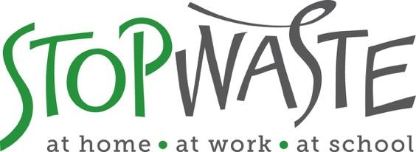

Reuse and Repair Focus Area
APPLICATION PACKET

DEADLINE:
Friday February 25, 2022
Applications must be received by 5:00 PM

StopWaste
1537 Webster Street, Oakland, CA 94612
(510) 891-6500 • www.StopWaste.org
Table of Contents

Reuse and Repair Grant Application 3
Project Budget 14
Standard Funding Agreement 14
Directions for Submitting Application and Supporting Documents 15
Appendix A – Example of Valid Insurance 16
Appendix B – Budget Spreadsheet Example 17

Reuse and Repair Grant Application
This is the application for Reuse and Repair Grants which provide funding for innovative projects that will increase individual, business, and community involvement in waste prevention, reuse, recovery, and source reduction efforts; encourage the development, marketing and use of recovered products while decreasing the amount of waste generated and sent to the County’s landfills.

The goal is to conserve natural resources and stimulate economic activity in the reuse and recovery sectors. Maximum grant request is $20k.

Please review the Waste Prevention Grant Program Information Packet before starting the application as it contains important details such as Grant Program Overview, Eligible/Ineligible Grant Activities, Proposal Evaluation Criteria as well as General conditions.

Grant Application Support

Applicants are strongly encouraged to work with StopWaste staff prior to submitting a grant application to ensure project concepts are eligible for potential funding. You may choose to attend an informational webinar, office hours, or schedule a one-on-one consultation with StopWaste staff:

- Informational Webinar – overview of all grant focus opportunities, applicant requirements, and opportunity to ask questions. January 20, 2022, at 4pm

- Office hours – held every Friday from 11 am-1 pm starting January 14th through February 18^{th,} 2022. To book an appointment, click here.

- One-on-one consultations – phone, virtual, and in-person support is available to help identify and work through project concepts as well as answer general questions about the grant program. Contact Meri Soll at msoll@stopwaste.org to schedule.

GRANT TIMELINE OVERVIEW:
- Grants Open: January 5, 2022
- Informational Webinar January 20th, 2022 at 4:00PM (Register Here)
- Grant Applications Due: February 25, 2022
- Grantees Announced: April 11, 2022
- Grant Funding Agreements Executed: June 1, 2022

General Information
Organization Name:
Website:
Contact Name (first and last):
Email Address:
Project Name:
Grant Amount Requested (max. $20,000): $
Total Project Budget: $

Organization/Business Overview
Briefly describe the history, purpose, and primary activities of your organization or business. Indicate the qualifications of your organization to provide the proposed services and note any similar projects previously implemented by your group. Indicate your geographic area of operations, community providing services to, and the primary sources of financial support for your organization.
300 words max

Project Details
Describe the specific purpose for which you are requesting funds.
- Include project design, primary activities, and essential equipment involved. Past grantees seeking additional grant funding to include how outcomes build on previous accomplishments.
- Indicate overall goals of the project, project implementation timeline (from start to end), and the anticipated impact of the project. Goals should be specific, realistic, timely, and measurable.
- Define the target focus of your project, including materials, waste generating sectors, and populations.
500 words max

- Statement of Need and Impact
- Identify the issue, need, or gap your project seeks to address. Describe how your project will be inclusive, not duplicate efforts of other organizations doing similar work.
- Provide details on the communities/businesses that recovered materials are distributed to.
- Does your project provide any benefits to the audience served and/or other community members beyond waste prevention? Examples may include job training and/or employment for under-served community members, opportunity to build community and increase connectivity among community members, serve unmet needs such as increasing food security, etc.

- Waste Diversion
- Quantify the amount and types of material(s) that will be prevented, reused, or recovered. Explain the methodology by which you will measure diversion, e.g., use of scales, counts of containers or materials, software, estimated waste based on volume, etc.
- For education-based projects, include audience, geographic area, and number of people expected to be reached due to outreach efforts.

5. Project Operations
  - List the personnel, with position titles, who will work on the project. Indicate their relevant past experience and their primary responsibilities under this grant.
  - List any applicable permits or licenses needed for project activities.
  - Will any driving be involved for the proposed project? If yes, please describe (will staff or volunteers be driving, in personal or company vehicles, etc.).

6. Project Monitoring
  - Indicate how program performance will be monitored and measured; explain how you will determine the success of the project.

7. Cost Effectiveness
  - Describe why the project is an efficient use of public funds and resources.
  - Where applicable:
  - state the estimated cost savings in solid waste diversion,
  - the extent of economic activity generated through the reuse/recovery of goods, food, or other materials,
  - the savings realized through a recovery program,
  - the number of jobs created by this project, etc.

8. Partnerships
  - Describe any cooperative or collaborative efforts with other organizations that are specific to the implementation of the proposed grant activities.
  - Describe other project participant roles and indicate how resources are shared and service duplication avoided.

9. Equity and Community Involvement
Referring to your proposed project and/or your organization’s work in general, please describe efforts to advance equity and inclusion in your organization, in your community, and/or through your programs and services in one or more of the following areas:

- Increasing access for those in need of food, products and /or services.
- Job training and creation of jobs for marginalized and/or under-employed community members.
- Working with and supporting community organizations in your community.
- Improving the community by offering education, training, recreation or other lacking services.
- Other

NOTE: If you have addressed equity and community involvement in response to previous questions, no need to repeat. Just reference the question response(s) that contain(s) the information.

10. Long Term Self-Sufficiency
StopWaste aims to invest in projects that demonstrate a commitment to sustainability that do not rely on continuous ongoing support from the grants program. Discuss how the project will become financially viable and self-sustaining after the expiration of the current grant. Provide details on how future expenses will be met. E.g., fee for services/products or funding from other organizations, memberships, events as well as absorption of the project into the overall budget of the organization.

vbhgjgghfj

Project Budget
All applicants must utilize our standard budget form that shows the proposed project includes a reasonable itemized budget and leverages other resources (matching grants, in-kind support, service fees, sales, etc.)
The applicant must provide details in the standard budget form on how requested funds for this grant will be used. If the proposed grant request is only a portion of what the applicant needs to implement the proposed project, the applicant must include additional funds needed and source of those funds in order to complete the project in the standard budget form.
Download the template spreadsheet, save as a PDF and follow the submittal directions below. Sample of a completed budget available in Appendix B.

Standard Funding Agreement
By submitting this application, you certify that:
- You have reviewed the Agency’s standard funding agreement available at http://www.stopwaste.org/resource/recycling-board-sample-funding-agreement and, if awarded funding, your organization will comply with all of the terms set forth in the funding agreement. You will not request any changes to the basic agreement, items 1 – 10, Exhibits B and C.
- You understand that Exhibit A of the funding agreement will be customized to the grant project in regard to the scope of services, deliverables, and timelines associated with funding request but that no other changes to the standard funding agreement will be made.
- You understand that failure to comply with any of these requirements will result in StopWaste’s refusal to enter into a Grant contract with your organization.
- You maintain (or have acquired a quote from an insurance entity) that meets Agency’s minimum insurance requirements.
- You have reviewed StopWaste’s Grants Program and Financial Reporting Overview for further information detailing the Funding Agreement, Payment, and Reporting Requirements should applicant be awarded funds.

- You have reviewed Waste Prevention Grant Program Information Packet

- If selected for grant award, the individual or organization’s project manager may be required to submit a Statement of Economic Interest Form (Form 700) as required by the State Fair Political Practices Commission. You will be notified if you are required to complete this form upon award of funding – you do not need to complete as part of the application process

Directions for Submitting Application and Supporting Documents
- Save completed application (this Word document) as a PDF.

- Combine the following required documents into a singular PDF:
  - StopWaste Grant Application PDF
  - Project budget (download fillable template here)
  - Financial statements – Profit and Loss, Balance Sheet for Calendar years 2020 and 2021
  - Valid business license or 501C documentation
  - Proof of current insurance (or quote/estimate) that meet StopWaste requirements
  - If applicable: Letter(s) of Support (applicable only for projects with identified partners)

Links to external download sources for application materials will not be accepted (this includes Google Docs, Google Photos, Dropbox etc.). Singular PDF not to exceed 20MB. Help combining multiple PDFs available here.

3. Upload SINGLE PDF file (containing combined documents listed above) to www.stopwaste.org/grants/online-grant-submissions
Accessing and uploading documents and data takes additional time to complete, applicants should plan on spending at least thirty minutes to complete the application upload process.

Deadline: 5:00 p.m. on February 25, 2022

IMPORTANT DETAILS REGARDING THE 5:00 PM DEADLINE
- Completed application packets are due by 5:00 p.m. on February 25, 2022.

- Incomplete, mailed, emailed, or faxed submissions will be automatically disqualified.

- The application submittal process includes uploading an application AND additional data via the StopWaste Grant Submissions Portal.

- Please take the time to familiarize yourself with the application and submittal portal and required documentation submissions and formats well before the deadline.

- The Submissions Portal shuts down promptly at 5:00 p.m. on February 25, 2022, submissions that are in process will be aborted. The system will send an automated message notifying you if your application was received on time. If your application is not fully uploaded prior to the 5:00 p.m. deadline, it will not be considered for funding.

Appendix A – Example of Valid Insurance
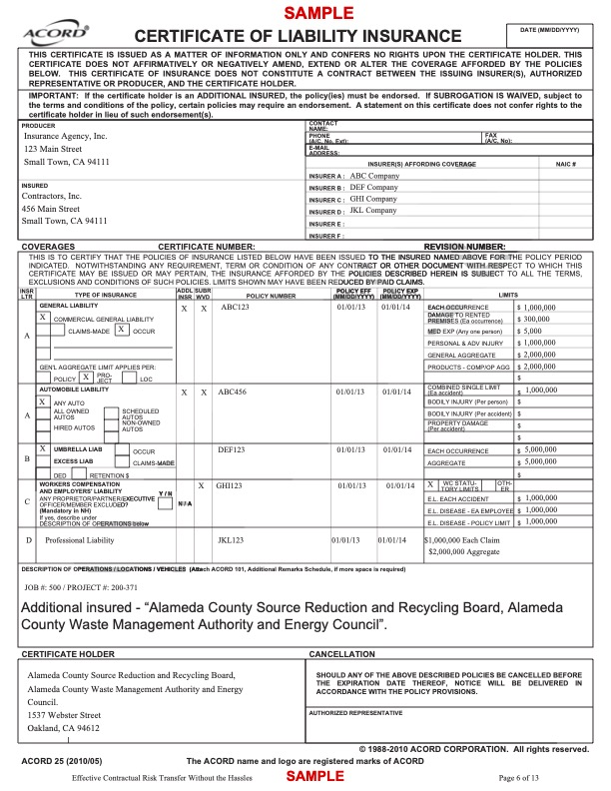

Appendix B – Budget Spreadsheet Example
